SERVICE/MAINTENANCE


APPLIANCE SPECIFICS |  | OBSERVATIONS
Asset number
Type of appliance
Appliance make
Appliance model
Location of appliance
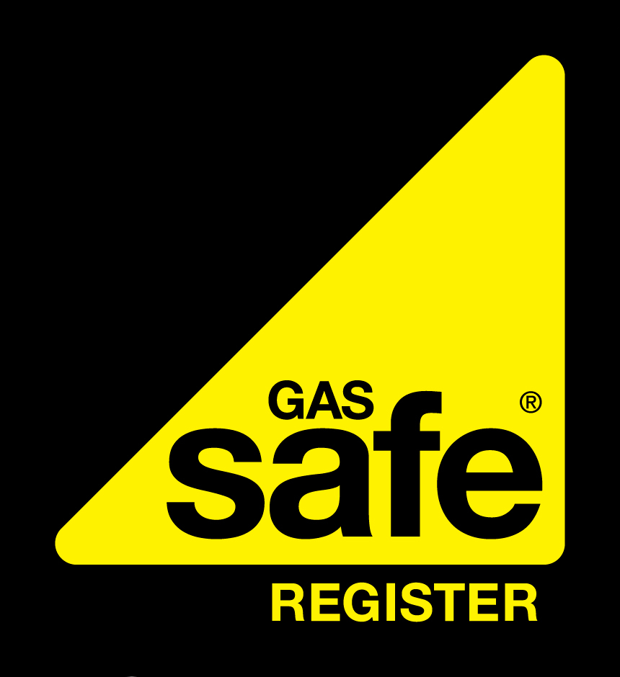
To confirm the validity of the Registered Gas Engineer please contact Gas Safe on 0800 408 5577 or www.gassaferegister.co.uk
To confirm the validity of the Registered Gas Engineer please contact Gas Safe Register on 0800 408 5577 or www.gassaferegister.co.uk
COMPANY NAME  Gas Safe Reg No: 000000  W: WEB E:EMAIL  Job Number: | CLIENT DETAILS
 | Name:
 | Address:
 | Postcode:
 | Date:

APPLIANCE INSPECTION
BURNER / INJECTORS |  |  |  | CONTROLS |  |  |  |  | IGNITION |  |  |  |  | HEAT EXCHANGER
Yes/No/NA |  |  | List defects and/or remedial action below | Yes/No/NA |  |  |  | List defects and/or remedial action below | Yes/No/NA |  | List defects and/or remedial action below |  |  | Yes/No/NA |  | List defects and/or remedial action below
ELECTRICS |  |  |  | WATER / GAS LEAKS |  |  |  |  | GAS (CONNECTIONS) |  |  |  |  | PIPEWORK
Yes/No/NA |  |  | List defects and/or remedial action below | Yes/No/NA |  |  |  | List defects and/or remedial action below | Yes/No/NA |  | List defects and/or remedial action below |  |  | Yes/No/NA |  | List defects and/or remedial action below
SEALS |  |  |  | CLOSURE PLATE |  |  |  |  | FLAME PICTURE |  |  |  |  | FAN (s)
Yes/No/NA |  |  | List defects and/or remedial action below | Yes/No/NA |  |  |  | List defects and/or remedial action below | Yes/No/NA |  | List defects and/or remedial action below |  |  | Yes/No/NA |  | List defects and/or remedial action below
FIREPLACE VOID |  |  |  | LOCATION |  |  |  |  | RETURN AIR |  |  |  |  | STABILITY
Yes/No/NA |  |  | List defects and/or remedial action below | Yes/No/NA |  |  |  | List defects and/or remedial action below | Yes/No/NA |  | List defects and/or remedial action below |  |  | Yes/No/NA |  | List defects and/or remedial action below
SAFETY INSPECTION
FLUE FLOW TEST |  |  |  | FLUE TERMINATION |  |  |  |  | VENTILATION |  |  |  |  | WORKING PRESSURE
Yes/No/NA |  |  | List defects and/or remedial action below | Yes/No/NA |  |  |  | List defects and/or remedial action below | Yes/No/NA |  | List defects and/or remedial action below |  |  | Yes/No/NA |  | List defects and/or remedial action below
SPILLAGE TEST |  |  |  | SOUNDNESS TEST |  |  |  |  | SAFETY DEVICE (s) |  |  |  |  | OTHER
Yes/No/NA |  |  | List defects and/or remedial action below | Yes/No/NA |  |  |  | List defects and/or remedial action below | Yes/No/NA |  | List defects and/or remedial action below |  |  | Yes/No/NA |  | List defects and/or remedial action below
RESULTS - Answer Yes (Y) or No (N)
Indicate appliance/Installation safe for use |  |  |  |  |  | Has a Warning Advice Notice been issued? |  |  |  |  |  |  | Has a Warning Label been attached?
List necessary remedial work:

Engineer | Name | Signature

SERVICE/MAINTENANCE
*Affix Electrical Bonding Label Here

Address Section:
- Complete the registered business details and inspection address
- Indicate Yes or No if the property is rented accommodation
- Indicate the type of work being undertaken and the result of the gas tightness test if required
Appliance Specifics:
- List the appliance type, make, model and location. Ensure that the location is acceptable for the appliance type.
Appliance Inspection: (to be marked Yes, No or N/A
- The main burner, pilot and injectors should be stripped, dismantled and cleaned. Visually inspected for damage or deterioration. Remove any dust/lint from the burners and air ports.
- The heat exchanger should be cleaned and checked. A visual inspection should be carried out for signs of distress.
- Check ignition for correct lighting of burners.
- Check condition of electrics.
- Check the controls for correct operation.
- Any gas/water leaks are repaired or where appropriate, the appliance/installation made safe.
- All disturbed gas connections are checked for gas tightness.
- All appliance case securing screws and case seals are checked.
- Gas pipework is installed correctly, and where visible, is adequately supported and protected. It should be corrosion protected within a builders opening, sleeved and sealed where passing through walls.
- Inspect and clean combustion fan and where appropriate the warm air circulating fan and filter.
- Inspect the fireplace opening and check any void/catchment space is correctly sized and clean. Check the chimney throat area for damper/debris. Pipe ducts and voids are properly sealed; spaces between flue liners and the base of the chimney are properly sealed.
- Where appropriate check the closure plate is correctly sealed and suitable for the appliance.
- Visually check for flame picture.
- Confirm appliance is suitable for the location.
- Check that the appliance has been installed securely with means of restraint in accordance with the manufacturers’ installation instructions.
- If a warm air heater, is the return air ducted correctly and correctly sealed?
Safety Inspection:
- Is the ventilation location and size correct for the installation? If the appliance is installed within a compartment; is the ventilation correct and from the same source?
- Check that the flue route and materials are suitable. Have joints been sealed correctly?
- Is the flue termination correct for the flue/appliance type, location correct and a terminal guard fitted where necessary?
- Carry out a flue flow test, checking for clearance of smoke.
- Carry out a spillage test in accordance with the appliance manufacturer’s installation instructions.
- Has the appliance burner been set to the correct working pressure and/or heat input as required on the manufacturer’s data badge?
- Are all safety devices operating correctly?
- Combustion analyser reading – where applicable, using an electronic portable combustion gas analyser, enter details
of the combustion performance. Ratio/Carbon Monoxide reading recorded.
- Check the installation complies with all other regulations. e.g building regulations.
- Where appropriate, has electrical bonding been carried out?*
Results:
- Where a gas safety defect has been
identified, issue a Warning/Advice Notice
recording the notice serial number.
Where appropriate attach a Warning Label
in accordance with the current Gas Industry
Unsafe Situations Procedure.
- List all defects not rectified on this visit.

